Alex van der Meer  
Student number: 10400958

Questions Reading 4

1. Patterns and colors are essential to maps. Compare a search for Harvard University on two interactive maps (e.g., Google Maps, Bing Maps, Yahoo! Maps, Apple Maps, map.harvard.edu). Answer the following questions, making references to concepts explained in Ware such as pattern recognition and properties of color. Please include screenshots of the examples you are comparing.

I chose using the Bing map and Google maps

* 1. Which map promotes an easier visual search for buildings?

In Bing it is easier to find out where all the Harvard buildings are. This is because Bing included the following feature. When one hovers over one of the buildings all Harvard buildings become light blue while the background remains grey, also there is a bold black line around the buildings. This massively increases the contrast between Harvard buildings and non-Harvard buildings. But even without the hovering, Bing has made a visual group of the Harvard Buildings by making them blue, while normal buildings are grey. Google does not do this. In figure 1 the Hovering in Bing is shown next to the representation of Google.   
When one wants to explore which buildings are where, things are different. For smaller buildings on campus in google maps the names of those buildings are not shown. Only when clicking such a building it gives the name. For Bing the names of smaller buildings are displayed when the user zooms in more. This makes it easier to search and explore the buildings on the campus. This is shown in figure 2.

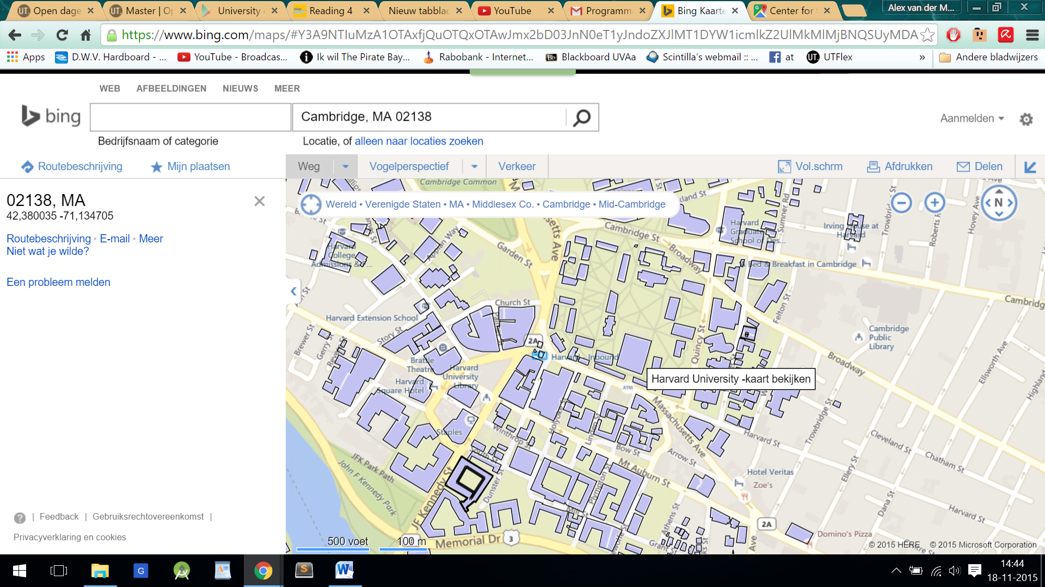 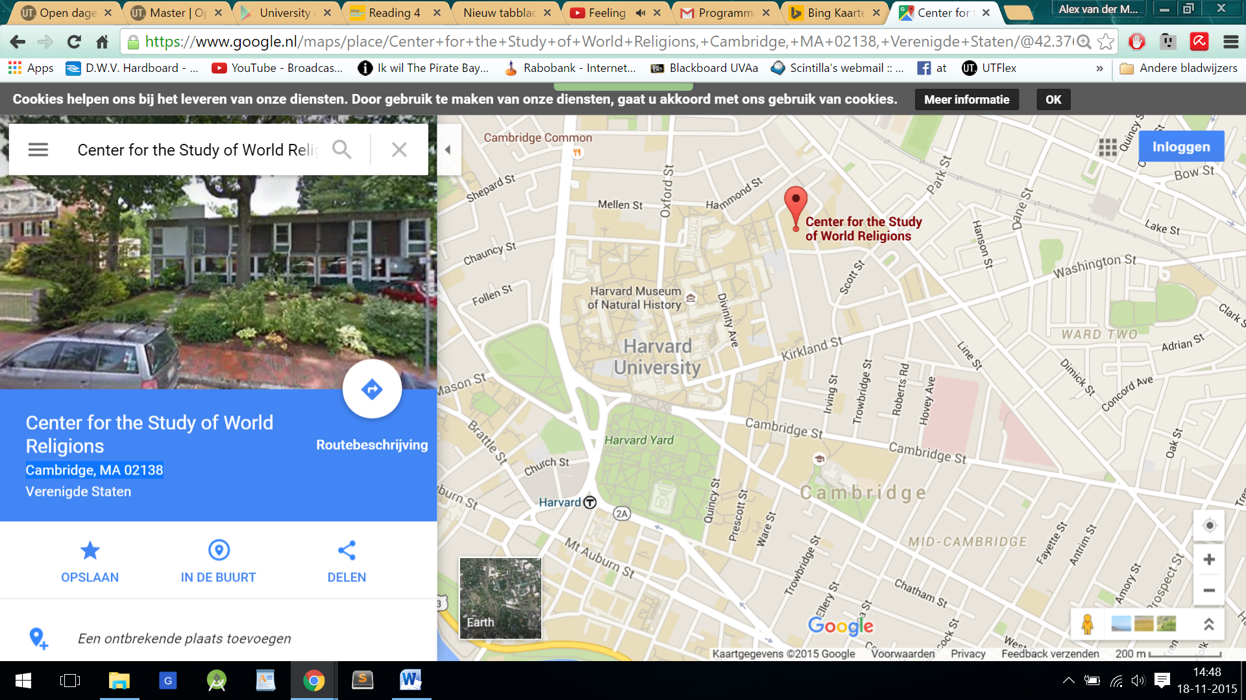  
Figure 1. Left: Contrast by hovering in Bing maps. Right: Less contrast in Google maps

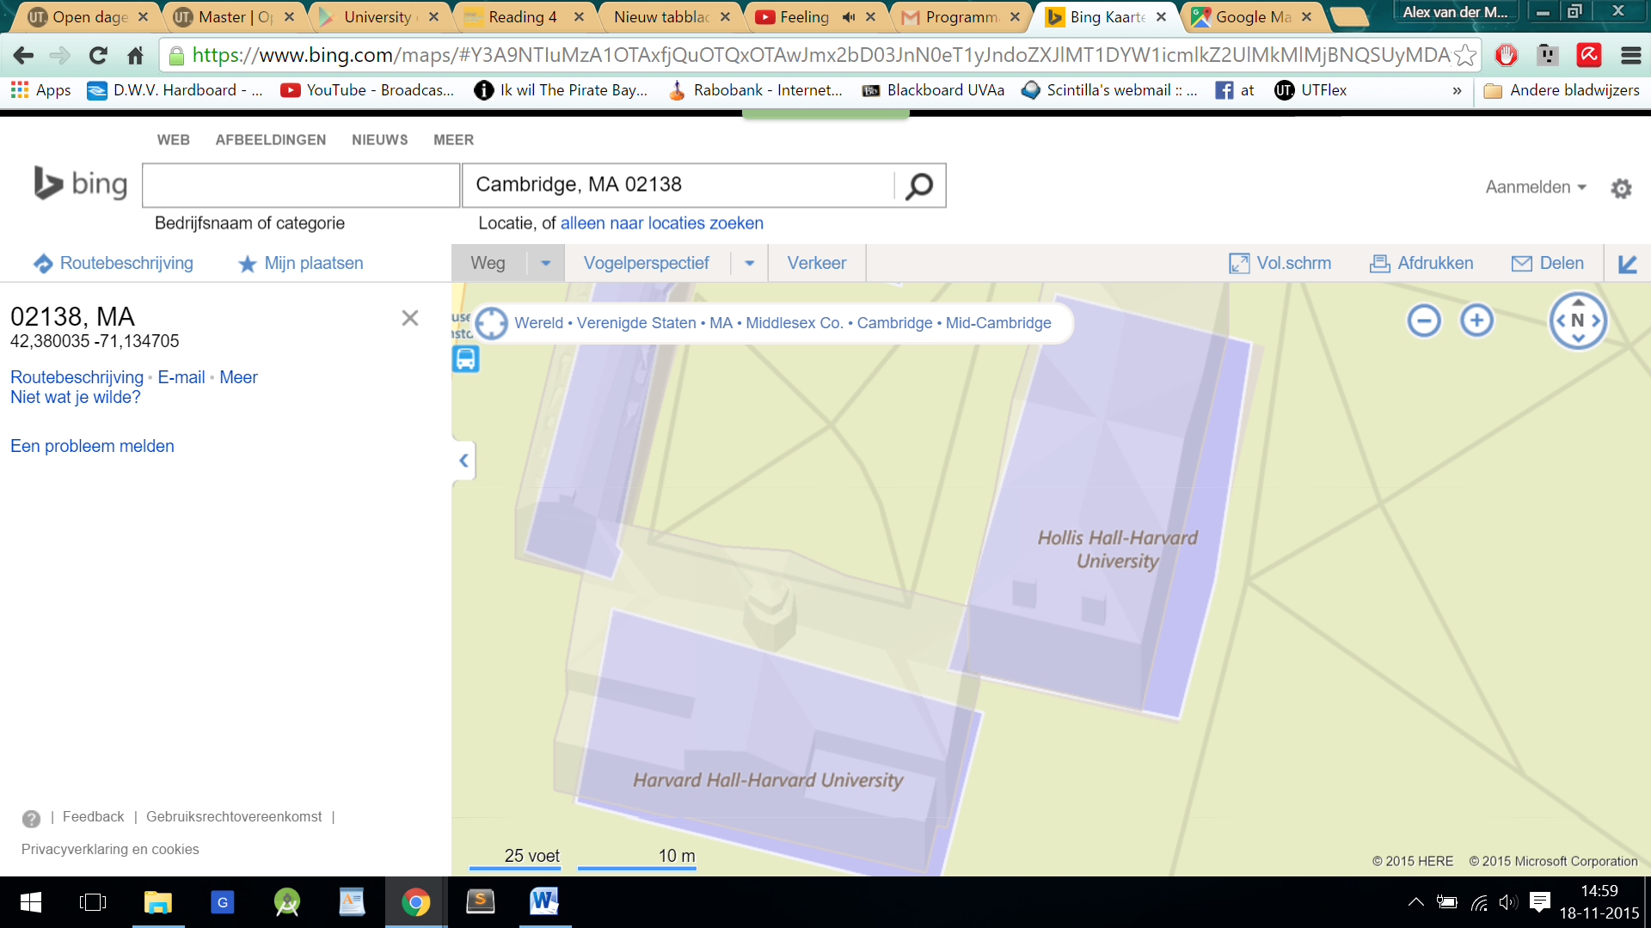 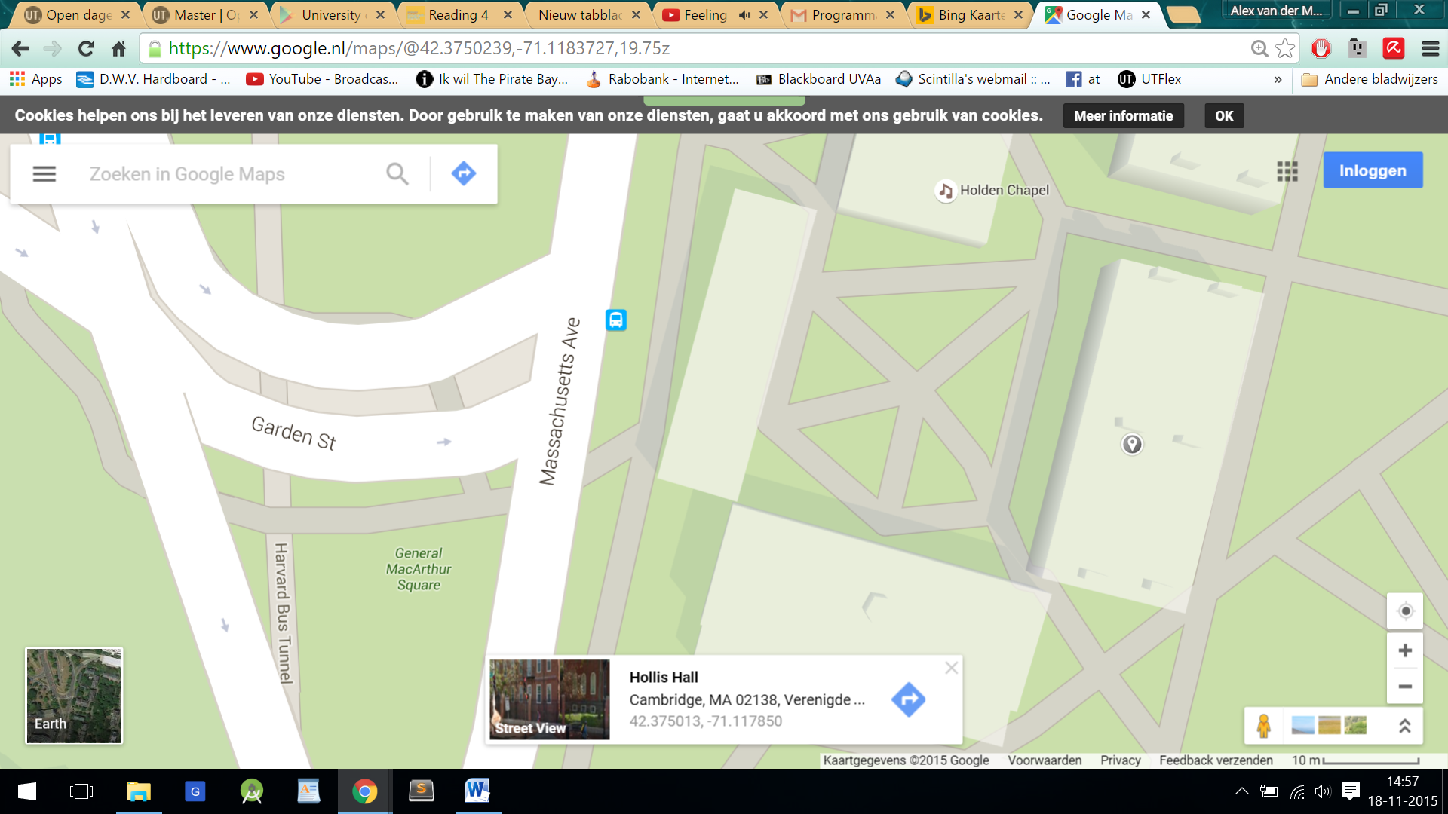Figure 2. Left: Exploring Building names in Bing Right: Google does not show the names of  
 Smaller buildings

* 1. Which map more effectively visualizes routes from a random point A to point B?

In my opinion Google maps does this better. This is because google maps colours the full width of the road to be followed, Bing only colours the centre. This causes the names on that road to be half in colour and half in white, this makes reading the names hard. Google has more contrast between the coloured road and the road names. See figure 3.

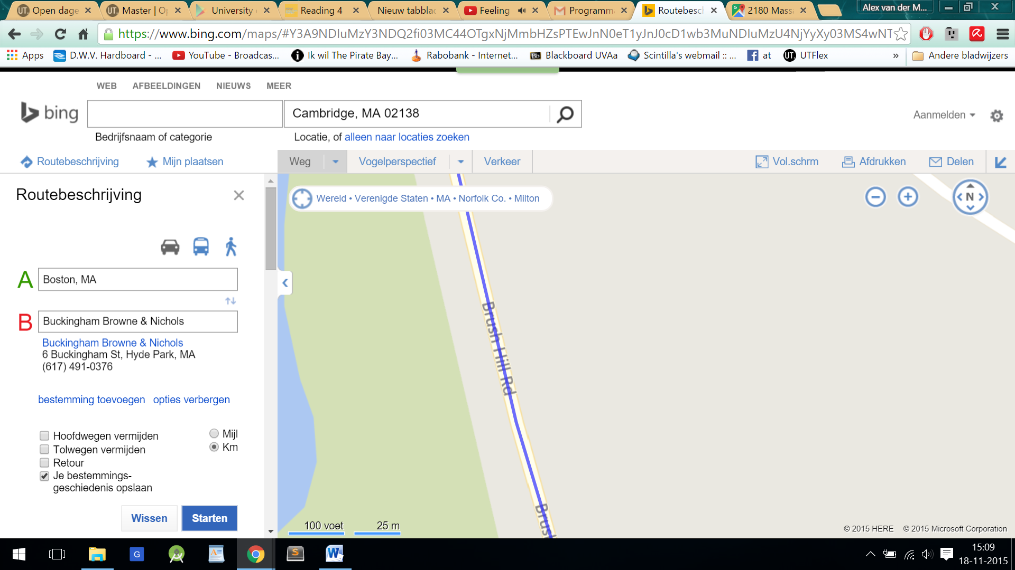 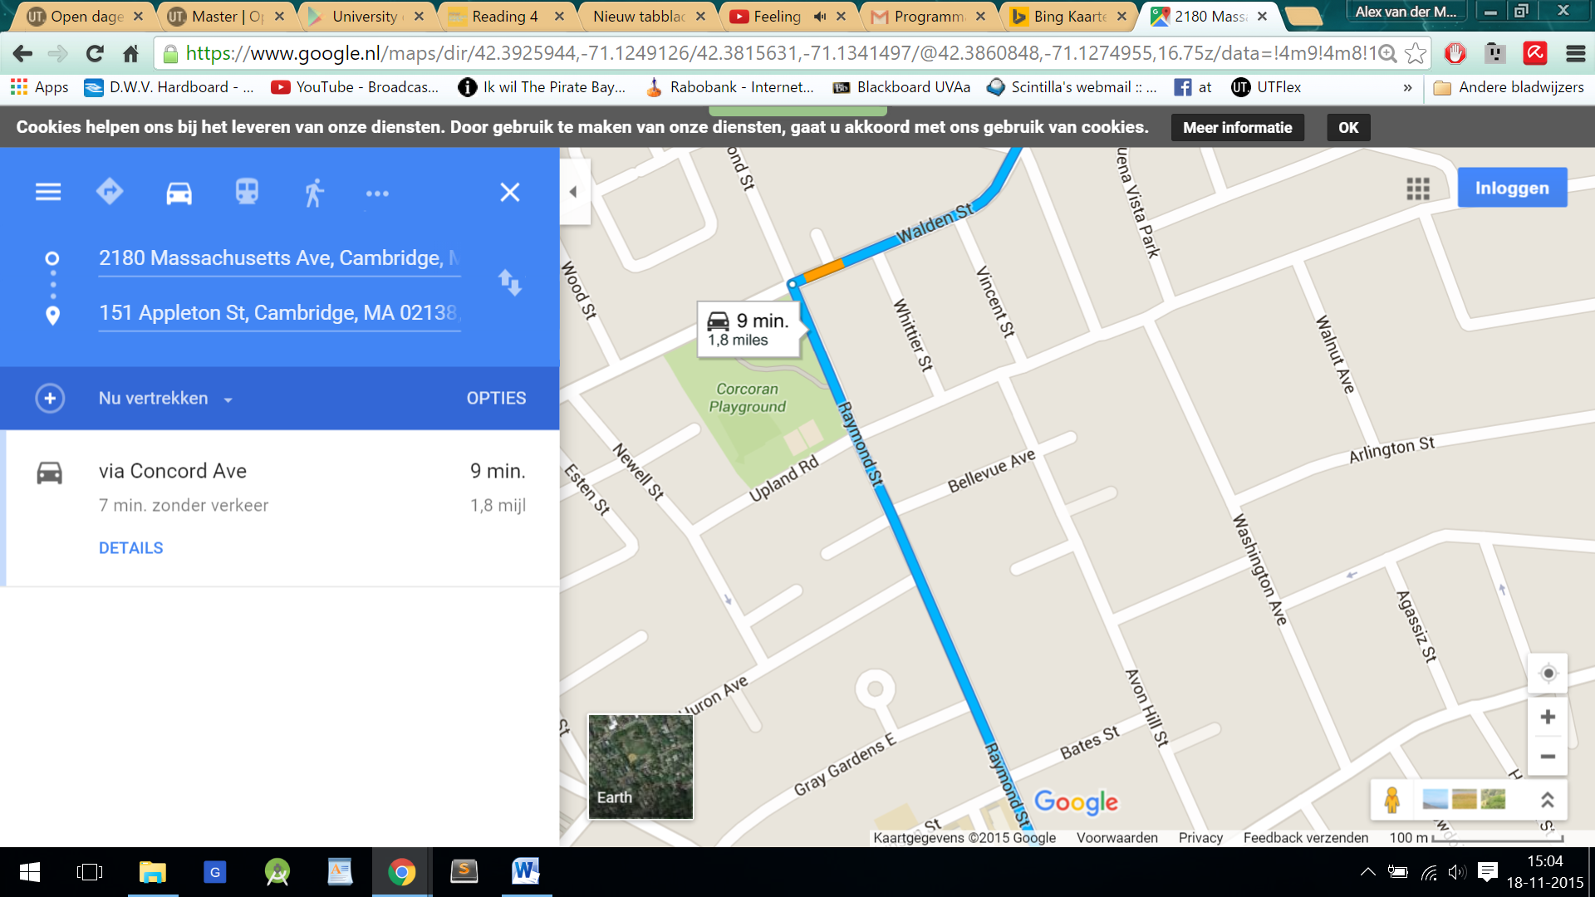  
Figure 3. Left: A route in Bing Right: A route in Google maps

* 1. Which map is an overall better visualization, and why?

Google maps, because more contrast is used and there is much less chart junk. That is Google shows less per zooming level, which makes important things easy to find and establishes a clear visual hierarchy. An example is given in figure 4. The use of purple in the Bing version provides less contrast then the orange in the Google version. Furthermore less overall saturation is used in the Bing version. But it seems like this is not a fault of the aesthetics designers but of the technicians because the resolution of the graphics is to low which makes it a bit blurry.

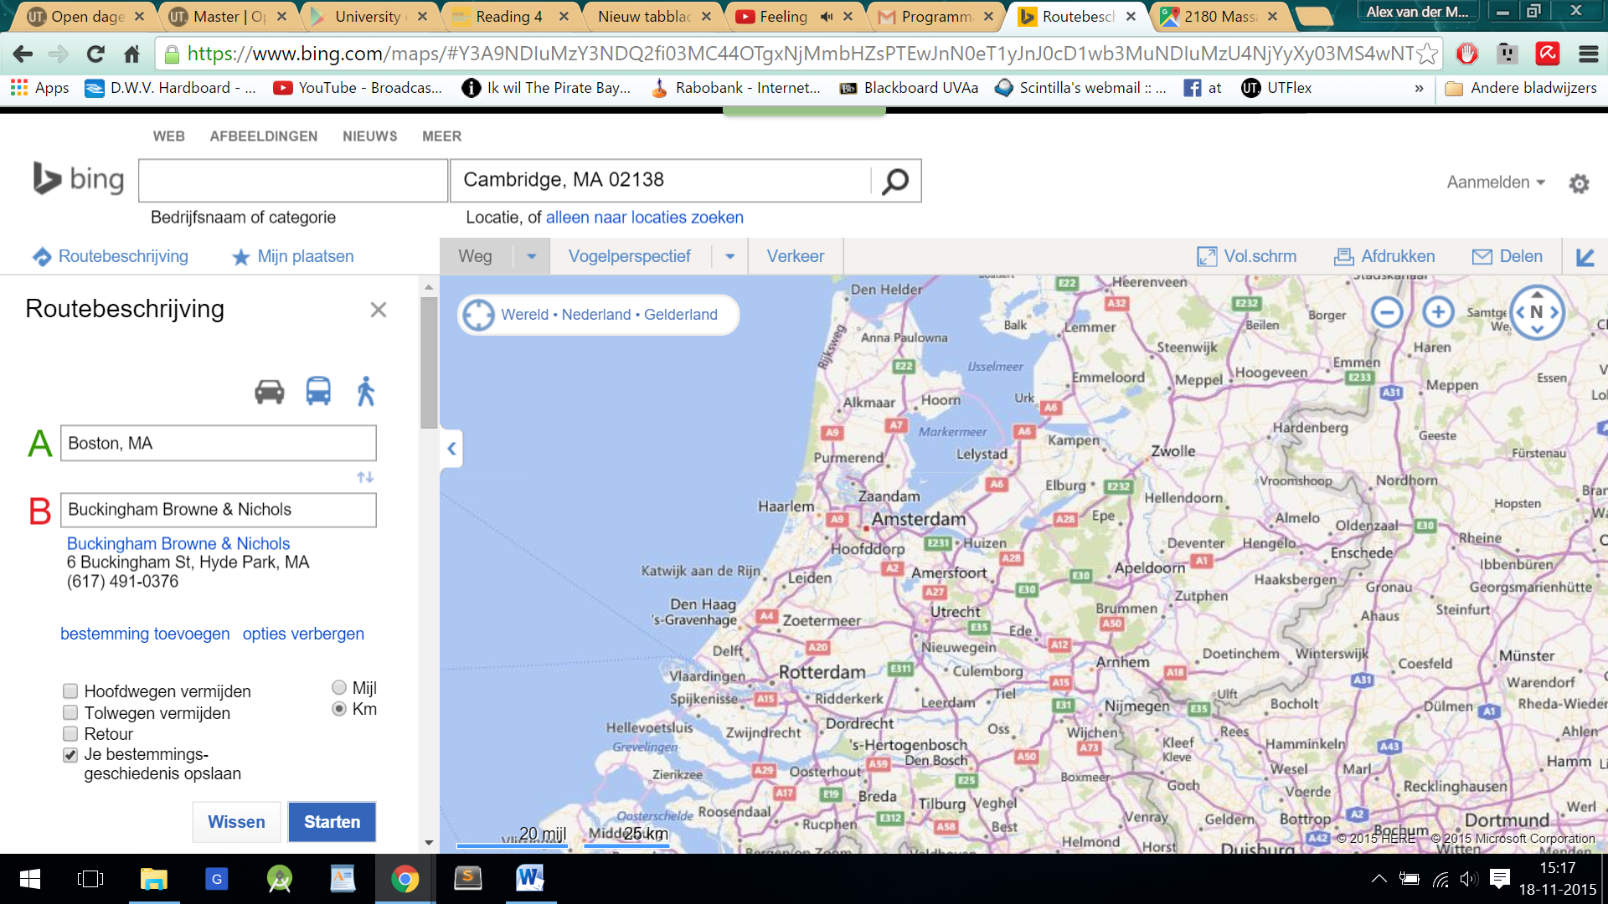 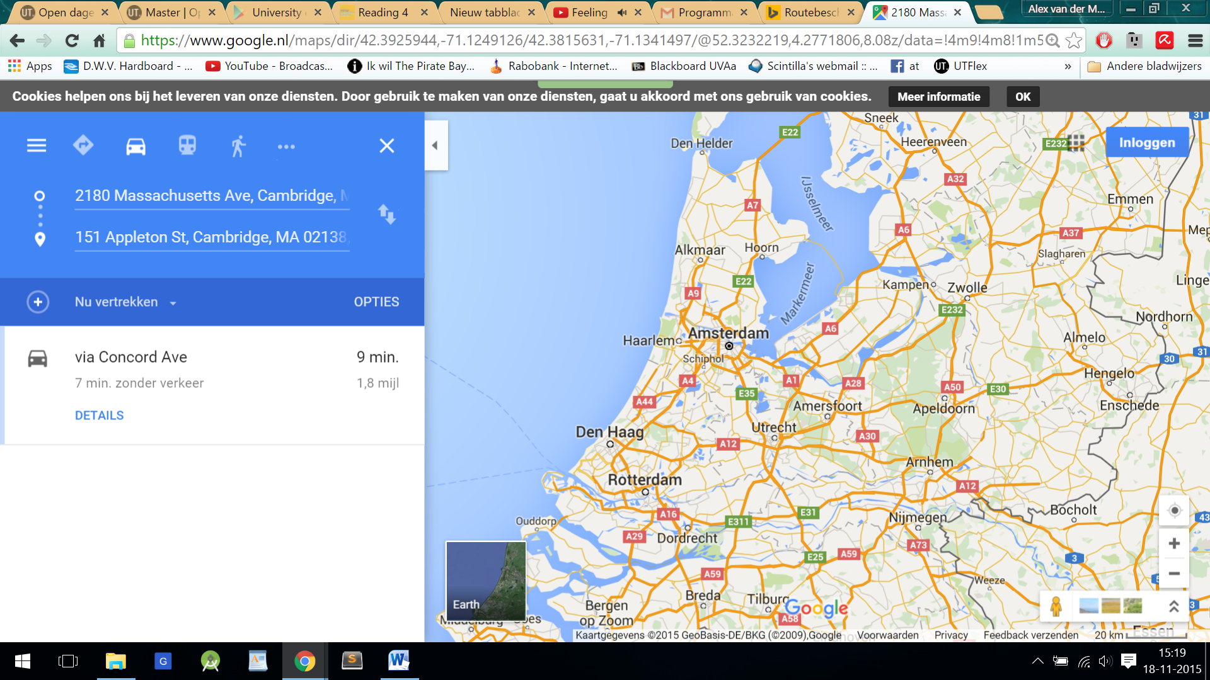

Figure 4. Left: A view of the Netherlands in Bing Right: A view of the Netherlands in Google maps

1. Find a rainbow color map visualization on the web. Please include a screenshot and link of the visualization.

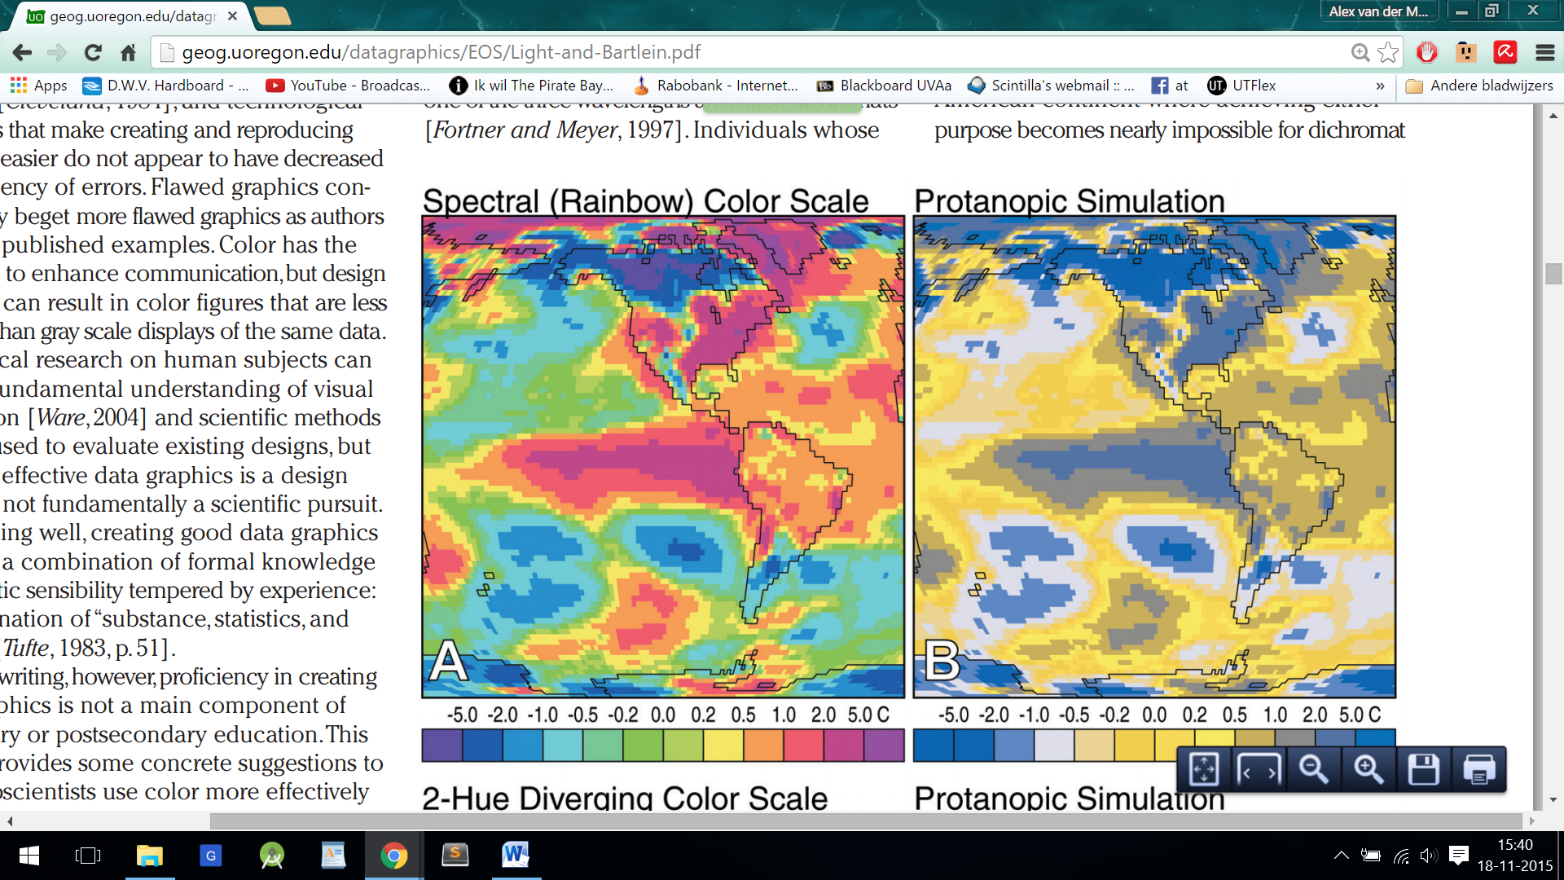

Figure 5. Rainbow map visualization of 2 meter temperature deviations.

* 1. Briefly summarize its intended objective and audience. Does it fail to successfully convey information? If so, why? Is there a good reason for this specific visualization to use a rainbow colour scheme?

The intended objective is to show two things. The data, (in figure A and B) the temperature deviations in this part of the world. The second objective is to show (in figure B) how this rainbow colouring would look when viewed by a person with a colour deficiency for red colours. This is based on psycho analysis models. It shows that the minimum values and maximum values look the same for a such a colour blind person.

Here it clearly does fail completely for colour blind people. But not completely for normal viewers. It is not intuitively clear what the middle, the minimum and maximum values are based on the colours. However since the different values are not randomly distributed over the visualization but there is gradual increase or decrease in regions, it is easy to link that with the legend. But yellow is given to much emphasis here in my opinion, it pops out of the picture while it stands for minor change in temperature.   
There is no good reason to use a rainbow colour map in this visualization

* 1. Propose an alternative colour scheme to replace the rainbow colour map  
     What would be better suited is a transition from blue to white to red. In this way the white stands for neutral red for heat and blue for cold, this is intuitive and draws attention to higher deviations from 0 temperature change.